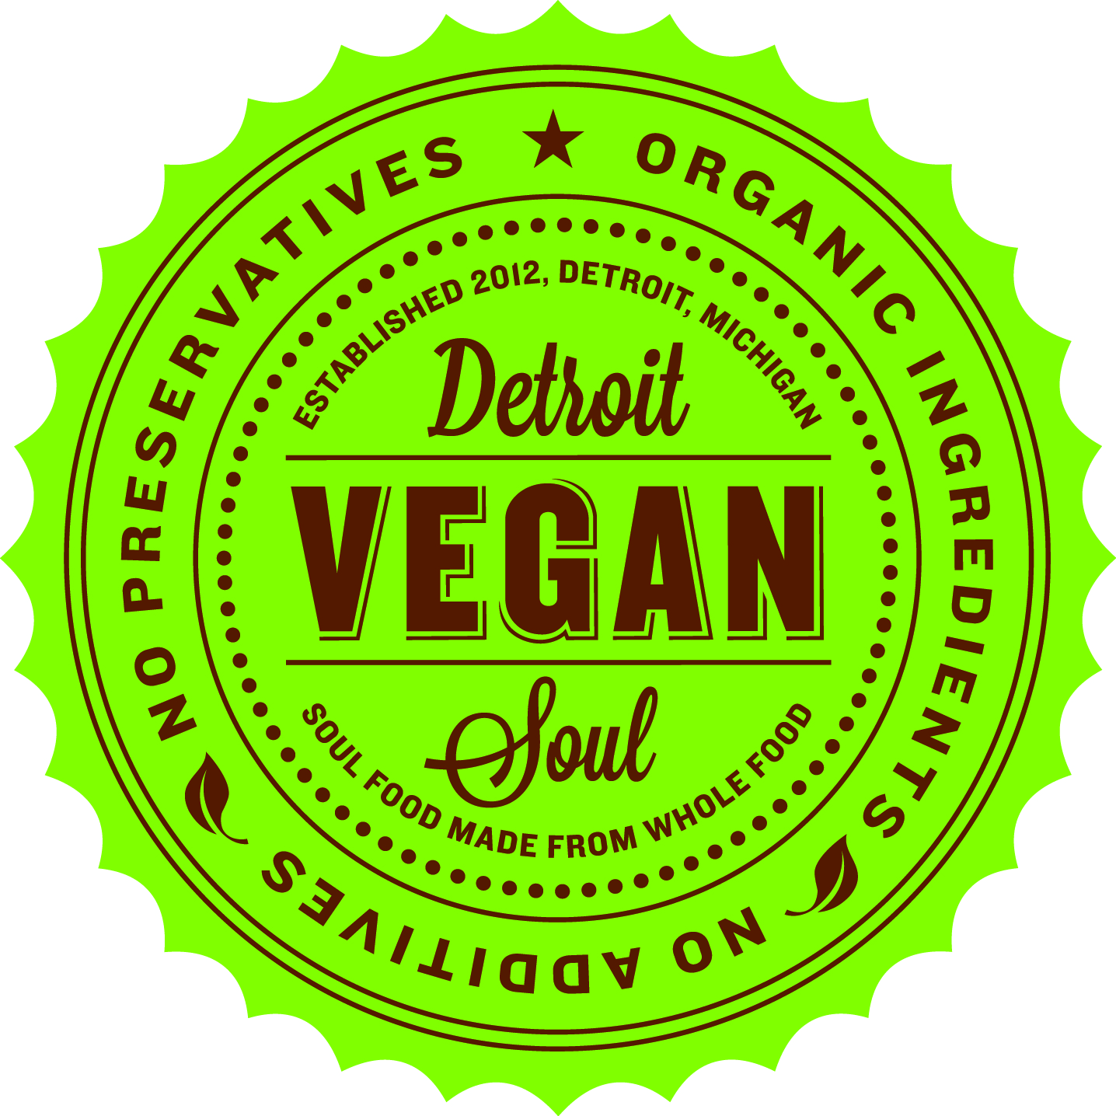

Detroit Vegan Soul and the Community

Our Mission & Vision
Our mission is to help people live healthier lives by providing great-tasting, high-quality, nutritious vegan food that appeals to everyone while at the same time doing our part to support a sustainable earth.

We partner with the following local vendors:
- Avalon International Breads (Bread)
- Michigan Soy (Tofu)
- The Brinery (Tempeh)
- Local farms for seasonal produce when available such as D-Town Farms

Some of the activities DVS engages in to further its mission:
- DVS is a founding member of FoodLab Detroit, a diverse group of locally-owned food businesses who support each other in the process of growing and improving our individual businesses, and who are committed to taking active steps together towards a more delicious, healthy, fair and green food economy in Detroit. DVS owners serve on a council of select FoodLab members where we are co-authoring a "good food, good jobs" strategy that will serve as a national model for deepening and spreading our understanding of how businesses can compete successfully, support good jobs, and respect worker rights.

- Beginning June 2017, DVS will partner with the Plant Based Nutrition Support Group and host their first small group meeting in the City of Detroit. https://www.pbnsg.org/event-calendar/2017/3/20/st-clair-shores-small-group

- From its inception, DVS has been concerned with making sure our food waste does not go into landfills. We have provided our food waste to D-Town farms and Earthworks. We are part of a team that is facilitating the creation of a sustainable food waste model for the West Village neighborhood that can serve as a model for the entire City of Detroit. This summer, EcoWorks' Youth Energy Squad (YES) program selected West Village in partnership with Eastern Market to host high school youth this summer to work with DVS in designing and testing a pilot program for food scrap collection and composting.

- At least twice per year, DVS hosts workshops for Detroit Public Schools (DPS) students through the Youth Energy Squad program where we discuss the health and environmental benefits of being vegan. The workshops include cooking demonstrations of easy meals youth can make at home.

- Annually, DVS hosts a 30-day vegan challenge with GO! Smoothies, where anyone can sign up for free to try being vegan for 30 days. We provide support to participants in the form of weekly workshops including a cooking demo, daily inspirational/motivational emails, a platform through the DVS website and social media pages to connect with all those participating, grocery store shopping lists and special discounts on weekly meal packages from the restaurant and on cleanse packages from GO! Smoothies juice bar.

- On October 8th, DVS will host Detroit's first ever outdoor vegan festival at Gabriel Richard Park.

- We provide a 10% discount to card carrying Sasha Farms members. SASHA Farm is the Midwest’s largest farm animal sanctuary. At their shelter, not only do they provide food and water, veterinary care and a roof over their heads, they also give the animal residents affection, social interaction with others of their own species, and a sense of security.

- DVS is a participating restaurant for the Grubbable app which is seeking to grow the local food movement. To do that, they team up with the best restaurants, farms, artisans, and non-profits in Detroit to offer an incentive for people to eat local for the health of individuals, the local economy, and the environment. https://www.grubbable.com

DVS has received the following awards:
- PETA Compassionate Business Award (2014)
- HOUR magazine's Best Vegan Restaurant in the City (2014, 2015, 2016)
- HOUR magazine's Best Soul Food (2016)
- Metro Times Best Soul Food (2014)
- Metro Times Best Vegan/Healthy Food Restaurant (2015, 2016)

Media/Press:
New York Times – “In Detroit: Revitalizing Taste By Taste” (2014)
CNN – “Best Cities for Vegans Around the World” (2017)

